Zachary Kuchar CardGames.org 2-27-19

For my senior project, I am planning to extend a class assignment. In my Web Systems class, I received an assignment for a Crazy Eights card game on the web. There were three different alterations of the assignment. One version played the game through alerts in the web page. The second version played the game with actual card graphics against a computer. You clicked on the card that you wanted to play, and you could click on the deck of cards to draw a card. The third version was played in the same way, but two different people connected to a server to play against each other. My project will involve taking this game, along with multiple other card games, and putting them on a fully fleshed out website.

This project will involve several different card games. Games like War, Go Fish, and many others may be included. These games will have updated graphics and some animations built into the gameplay. The website will also feature a login system. People can create a user ID and password, and then they can login to the site to play. When a person wins a particular game, their username, along with their score or best number of moves, will be uploaded to a database. This database will contain the scores of everyone who has achieved a good score on a certain game. You will also be able to view each of the scoreboards to compare yourself to others who are playing.

**Aesthetics and Functionality**

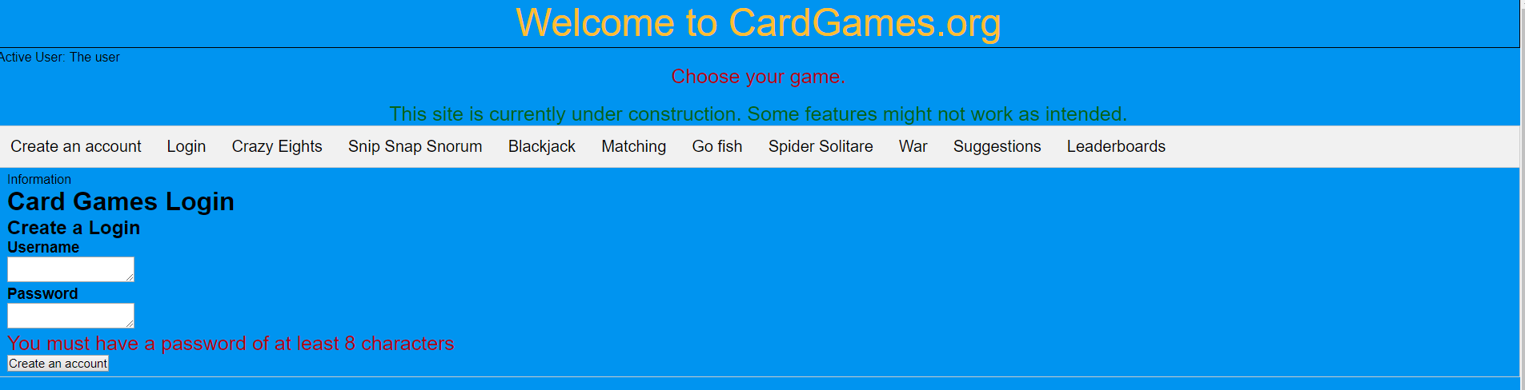

*Figure 1: Project look*

Using HTML and JavaScript, I wanted to create an original website. The website will have a title and tabs of the various card games. There will also be a tab for creating a login, one for each game, and one for a leaderboard. The setup will be easier for users to maneuver from game to game easily.

I started off with the graphical style for each game. Starting with Crazy Eights, I created the look for each of the cards and their layout. Then, I incorporated this layout into the other games, making modifications as needed. For games such as Go Fish and Snip Snap Snorum, the initial look did not need to change, for games such as War and Blackjack needed more modifications.

After creating the layout of the cards, it was time to work on their functionality. Crazy Eights involved clicking on a card image to perform a specific action. On your turn it required you to click on a card in your hand. This would call a function to see if that card could be played. If you needed to draw a card, you must click on the back-face card that represents the deck.

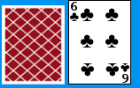 *Figure 2: Back and front of cards*

The next game was War. The functionality of this game was much simpler. All the player needed to do was press a button, and the game dealt out cards. From there the game would display the player’s cards and the computer’s cards. Then, the game would compare the card values and see which one was higher. The player with the higher valued card scored a point.

The final look of Blackjack involved a similar button intensive system. One button called for a function to deal a card, while the other allowed the computer to take its turn. This game required the need for the computer to keep track of the card values in each player’s hand. When the value was over twenty-one, the player would bust and lose. At the end of the game, the player who had the higher valued hand would win.

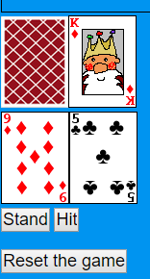 *Figure 3: Blackjack*

Snip Snap Snorum evolved clicking on both an image and a button. The player selects a card in order to play, but the turn does not pass like it does with Crazy Eights. The first card played during a round can be anything, but the second and third cards must match the value of the first card played. Playing a third card allows for you to start the next round. If you do not have a legal card to play, you must pass. The computer will proceed to play until it no longer has a legal card.

Go Fish has two different functions that can occur when you click on a card. You can either click on a card to ask if the computer has it or give all necessary cards to the computer player. A Boolean value is used to determine which action is necessary for the player to take. If you do not have the required card, you can hit a button to tell the computer to Go Fish.

The Match Game is similar to other simple card matching games. You flip over two cards to see if they are the same. If the cards are the same you get a point, if not, you try again until you get a match. At the end, you will get to see how many moves it took.

Spider Solitaire required readjusting the layout and display of the game. To make a move, you click on a specific card, and then the game transfers it along with the row. The next click attempts to move the chosen cards. If legal, the move proceeds. If not valid, the user is alerted of an illegal move. If no moves were available, it requires clicking on a new deck to deal out extras. When a row of cards contained the correct order, they were removed, and the player was awarded a point.

**Challenges/Problems**

Working on this project did not come without its fair share of difficulties. Calculating the values of the cards in games like Blackjack was time consuming and had its struggles. An error involving the way the values were being concatenated together took some time to figure out. The numbers would be combined into one big number instead of being added together separately (7+3 would make 73, not 10). I realized my mistake with the corrected code below. I needed to put a “+” sign in front of the values to be added. This added the numbers instead of making one number.



*Figure 4: code snipit. Using + sign to add numbers instead of concatenation*

A technical problem that arose with Blackjack was when the value of an ace came into question. I needed to determine how to properly incorporate both values of a one and an eleven. It proved to be difficult to effectively switch between the two values. As I tested different methods, I settled on the value of eleven and subtracted ten if the total hand value went over twenty-one. This method worked.

A few snags while working with Go Fish involved clarification whether asking for or receiving cards, as well as making sure the user could not play extra cards. I set up a Boolean variable to determine if the player needed to ask for a card or give a card to the computer. This allowed the game to determine the necessary action for the player to take.

With Spider Solitaire, the obstacles with card positions as well as functionality with card movement created multiple challenges. Making the card’s position absolute allowed for the display of cards vertically, instead of horizontally. The next issue involved the placement of cards properly. A two-click system seemed to correct the problem. The first click selected the cards to be moved, while the second found the section that they were to be moved to. This feature took some time to work correctly. In the end, I opted for an implementation that noted the cards to be moved, and then I determined if the move was valid. If it was legal, the cards were removed from their old row and placed into the new one.

Other challenges that needed attention were the ability to move a king into an empty row and remove the ordered row of descending cards from play to add a point. To move a king, we needed to see if a row was empty. By displaying the image of a card back with a value of “empty”, I was able to determine a legal move for a king. Removing a row of cards required examining a row and verifying if all of the necessary cards were in the correct order. If they were, it removed the cards. Otherwise, nothing happened.

Setting up the server

In order to set up online functionality, it required setting up the project in Node.js. I created a test server on Heroku, and then I converted the main project from PHP to Node.js. This enabled the setup of a WebSocket server, as well as the rendering of the webpage with the necessary CSS and JavaScript files. While I was familiar with setting up WebSocket servers with Node.js, I was not familiar with running a node server under Heroku. I was disappointed that the process of learning the necessary requirements and getting everything working took as long as it did. I had to use Express to load the webpage, and then do some finagling in order to load any extra files that were necessary. When this was solved, I needed to learn how to set up a WebSocket server so it could interact with Heroku. The only real change needed was the way that the WebSocket on the client end finds the server. Heroku’s forums suggested this code to allow my webpage to interact with my server properly.



*Figure 5: WebSocket client code*

Once set up, I was able to test if the server was working with some simple communication scenarios. I set up functions to send messages to the server, and have the server send messages back. An error occurred with the correct message being sent back, but this issue was just a simple if-statement problem. Once fixed, the server appeared to send and receive messages correctly.

Online mode

With the main server now up and running, I introduced an online mode for Crazy Eights, Sip Snap Snorum, and Go Fish. I did not give all the games this option. When playing Crazy Eights, the game would notify the server if it was going to play a card or draw a card from the deck. The server would send a message back with the essential information. My project was set up to send information through the web page itself since the WebSocket connection resided. A message was sent to the webpage, and then the webpage would determine which game to update. From this point, the server would update which cards were in the player’s hands. Lastly, I added a button to switch back to offline mode. When choosing this option, the current user could switch back to a normal version of the game. After selecting the offline mode, this sends a message to your opponent that you have left the game, and they will win by forfeit. Next on the agenda is getting the online capabilities for Snip Snap Snorum and Go Fish.